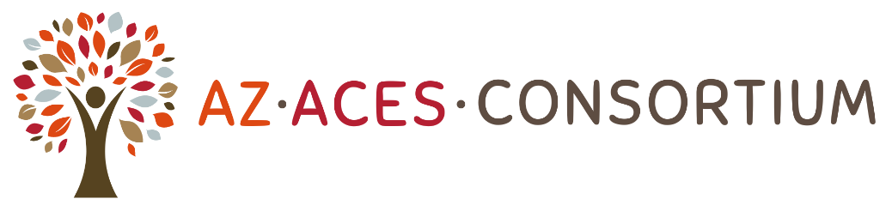
11th Annual ACEs & Resilience Summit- Resilience in Action is Connection
Workshop Proposal Form
The Arizona Adverse Childhood Experiences Consortium invites workshop proposals for our 11th Annual ACEs & Resilience Summit that will be held December 9th -12th , virtually, and will bring together 600+ professionals from a variety of sectors, including family/human service, government, nonprofits, law enforcement, healthcare, and early education. Workshops will be held on December 11th only.
Please read the following information carefully:
We welcome proposals from dynamic speakers for engaging workshops that will expand participants’ knowledge of effective approaches to addressing the impacts of Adverse Childhood Experiences and childhood trauma. This year, we are particularly interested in receiving proposals that focus on reimagining wellness within the following topic areas:
- Creating trauma informed communities
- Healing Inter-Generational Trauma
- The implication of ACEs on creating trauma informed organizational design and practice
- Trauma Informed Relationship Building Practices
- Trauma Informed Communication for Direct Service Providers
- Resilience building strategies

Important reminders for workshop presenters:
- Speakers are strongly encouraged to include implications for trauma informed communication in relation to your topic
- Speakers are strongly encouraged to include audience participation in their workshops and provide hands-on, practical applications of the materials presented.
- Speakers may not sell products or services during their workshop.

Please submit this completed form to information@azaces.org by Friday, September 20, 2024

Lead Presenter Information

Please note: If this workshop is accepted, the lead presenter listed below will receive a complimentary conference registration. The first co-presenter will receive the discounted registration rate of $75. Any additional co-presenters will be charged regular registration rates.
- Name:

- Title:

- Organization:

- Email:

- Phone:

- Please provide some background on your expertise, including your experience offering trainings/presentations:

Co-Presenter Information

(If no co-presenters, leave blank)
Please note: If this workshop is accepted, the co-presenter listed first below will receive the discounted registration rate of $75. Any additional co-presenters will be charged regular registration rates.
- First co-presenter name:

- Title:

- Organization:

- Email:

- Please provide some background on co-presenter expertise, including experience offering trainings/presentations:

- Additional co-presenter names, titles, organizations, and emails:
Presentation Information

If your workshop is selected, the Arizona Adverse Childhood Experience Consortium may edit the information you provide below for length/clarity.

- Workshop Title:

- Please provide a concise and captivating description of your workshop for our conference program (between 2 and 5 sentences):

- Please list 2-3 learning objectives:

- Please list 1-2 actionable takeaways:

- Detailed workshop description:

- Group engagement: What methods will you use to facilitate audience learning? (lecture, activities, visuals, etc.)

Other Workshop Details

- What is your preferred audience size?

- What audience is your workshop designed for?

- Is the content of your workshop for decision/policy makers or for practitioners (introductory, intermediate or advanced)?

- Additional notes/comments:

Thank you!
Please submit this completed form to information@azaces.org by Friday, September 20, 2024.
You will receive confirmation that your proposal has been received.
-If you do not receive confirmation, please contact Angie Burleson at angiemburleson@gmail.com .
You will be notified whether or not your workshop has been accepted by Monday, October 7, 2024 .

