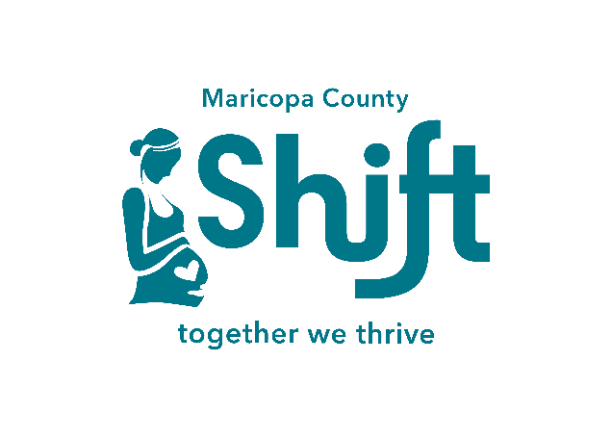
WHAT: Maricopa SHIFT (Safe, Healthy Infants and Families Thrive) is a new initiative, aimed at improving cross-system collaboration in a non-stigmatizing, trauma and infant mental health informed manner, for pregnant women with a substance use disorder. The only two qualifiers for participation are (1)- a pregnant parent and (2)- with a substance use disorder (SUD) of any kind. Any other system involvement, including an open DCS case or not, does not affect eligibility.
WHY: The national Opioid epidemic has impacted thousands of newborns throughout the U.S. Maricopa SHIFT aims at reducing the incidence of Substance Exposed Newborns (SEN), many of whom are affected by Neonatal Abstinence Syndrome (NAS) after exposure to opioids and other substances in utero. It has been demonstrated that EARLY ENGAGEMENT IN COLLABORATIVE, COMPASSIONATE SERVICES PRENATALLY, can greatly improve the outcomes for these newborns and their families in a multitude of ways.
WHO: Maricopa SHIFT is a collaboration of a variety of providers within Maricopa County for expectant parents affected by SUD. Examples include: MAT (Medication Assisted Treatment) and substance use treatment providers; Family Treatment Court; WIC (Women, Infants and Children); High risk maternal health care providers; Hushabye Nursery; AHCCCS; MCDPH, ADHS and others.
HOW: When you have a client who meets the above 2 criteria, tell them about SHIFT and how it can benefit them. Clients can self-refer by contacting us via email or phone; or, with their consent, you can refer them to us. We’re happy to answer any questions!

MARICOPA SHIFT WEBSITE: www.MaricopaSHIFT.com
MARICOPA SHIFT EMAIL: MaricopaSHIFT@maricopa.gov
PHONE: 602-526-6116 